# 3 Technology

## 3.1 Machine Learning Crypto Ratings

The Token Metrics Asset Allocator provides a platform for rating cryptocurrencies using machine learning algorithms that model Charles Darwin's Theory of Natural Selection. Genetic algorithms create well-performing solutions to optimization and search problems using biological concepts such as mutation, crossover, and selection.

A genetic algorithm contains five phases:

* Initial Population
* Fitness Function
* Selection
* Crossover
* Mutation

A genetic algorithm starts with a set of random individuals referred to as an Initial Population. The fitness function evaluates an individual's ability to outperform other individuals. Individuals with a high fitness score have a higher probability of being selected for future generations. Crossover is the process of mating two individuals by combining genetic information to create offspring. These two individuals become parents. A mutation is a process of inserting randomness into the creation of offspring to avoid premature convergence.

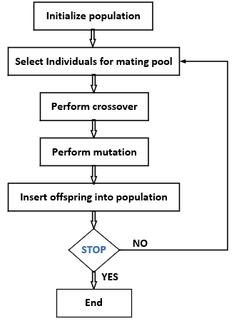

Figure 1: Genetic Algorithm

Token Metrics applies genetic algorithms to create evolving weights for cryptocurrency ratings. Weights are calculated by backtesting using the Fitness Function to maximize the accuracy by selecting from at least 100 generations and evaluating 500 random individual solutions from the population. The models’ complexity is O(n*m), where n is the generation, and m is population.

The best-performing weights are tested daily and made available by the Token Metrics team via Application Programming Interfaces (APIs) to the Token Metrics Asset Allocator. The rating weights that lead to the best investment performance are selected. Only the winning models are used to create the official Token Metrics Indices, the crypto industry’s most thoroughly tested crypto ratings.

## 3.2 Machine Learning Crypto Indices

Token Metrics Indices take machine learning crypto ratings and build investable portfolios.

Each grade based index creates a portfolio based on up to 30 of the highest graded cryptocurrencies present in Token Metrics. Rebalancing consists of grade weights, achieved by dividing the grades by sum of grades. The indices reallocate capital away from tokens with low grades to tokens with high grades.

The price prediction indices create portfolios based on up to 30 cryptocurrencies with the highest predicted returns. The indices are composed of cryptocurrencies with an average price prediction accuracy greater than 80% in the last three months, and a predetermined minimum daily trading volume requirement. Price prediction indices rebalance using grade weights, achieved by dividing the grades by sum of grades and allocate capital to the highest graded tokens.

All indices contain at least ten different cryptocurrencies and at most 30 different cryptocurrencies. A cryptocurrency present in indices may or may not be present in the next portfolio rebalancing. Indices divide into different time horizons:

* Daily Indices
* Weekly Indices
* Monthly Indices
* Quarterly Indices
* Yearly Indices

Monthly Indices rebalance on the first date of every month. Daily, Weekly, Quarterly, and Yearly Indices rebalance after 1, 7, 90, and 365 days.

## 3.3 Portfolio Optimization Using Crypto Ratings

The birth of Quant Investing goes back to the 1950s, and at its foundation is the Modern Portfolio Theory (MPT) of Harry Markowitz. Although the notion of diluting risk through diversification was known before then, Markowitz provided a mathematical framework to minimize risk and maximize the expected return of a portfolio by optimizing capital allocation. His method is referred to as the Traditional Mean-Variance Approach and has been the basis for modern portfolio theory for more than half a century.

However, in the practical world, this method proved to have minimal impact. Practitioners noticed that the mean-variance approach produced unintuitive, extreme portfolios that were very sensitive to inputs and estimation errors.

While at Goldman Sachs, Fischer Black and Robert Litterman built the Black-Litterman asset allocation model in 1990 to address and overcome the practical issues of the mean-variance approach. The model uses a Bayesian approach to combine the market equilibrium or capitalization weights portfolio with forward-looking subjective views on the portfolio’s assets in the form of expected returns.

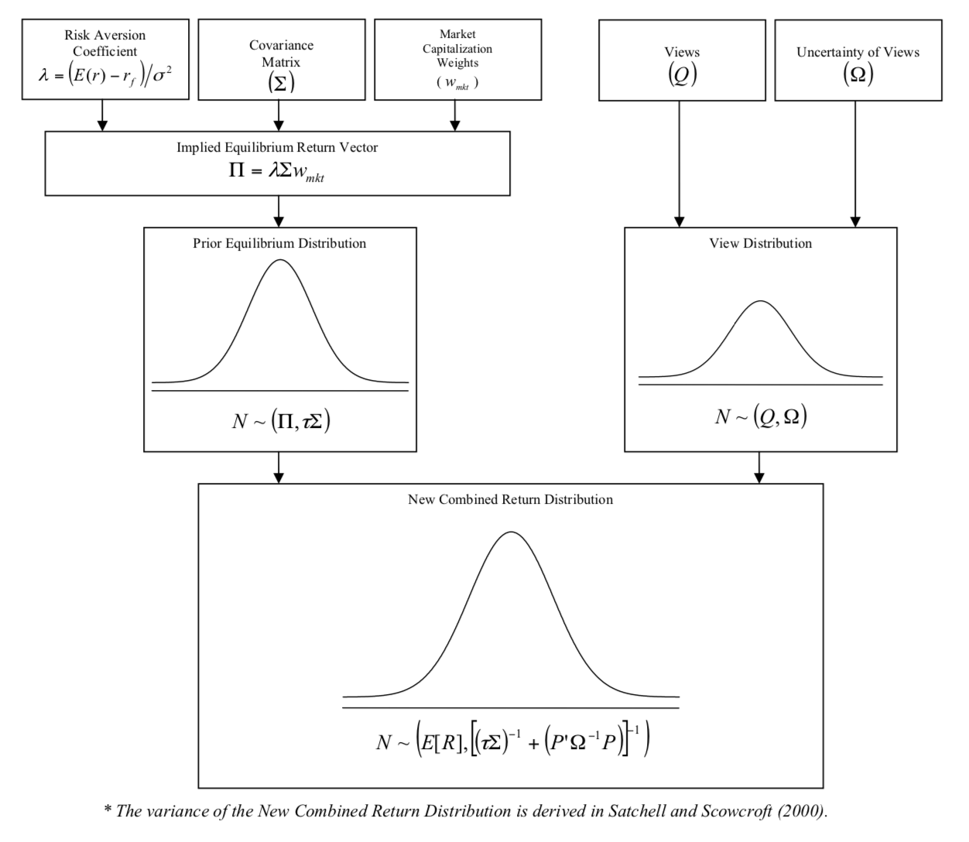

Figure 2: Black-Litterman Formula

The Black-Litterman model provides superior risk-adjusted returns and lowers risk compared to traditional mean-variance optimization. The first step in our Black-Litterman model is that the indices are implied from the market cap weights. This starts off with a market portfolio. Then views related to Token Metrics rankings, scores, and price predictions are used as inputs to optimize the indices allocations. Using this model to construct the Token Metrics Indices, investors benefit from Token Metrics proprietary ratings, scores, and machine learning models by merely holding the indices.

A visual representation of this powerful model is shown in the chart below. As subjective views, the Token Metrics rankings were used as follows:  
  
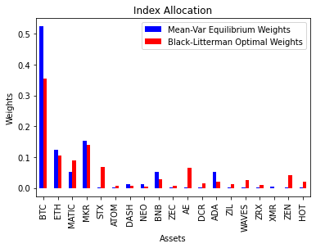

Figure 3: Black-Litterman Optimal Capital Allocation Using Token Metrics Rankings  
  
In this example, Token Metrics Value-Investor Rankings are used as views.

The Token Metrics Rank is subtracted from the Market Cap Rank, and the higher this value, the better the likelihood of performing well.

Example: MATIC Token Metrics rank in the example is three while it’s crypto market cap rank is 99, so the view says that MATIC should perform well.

All views are expressed in terms of % expected return.

It is worth mentioning that all these portfolio optimization models have assumptions that could cause problems outside the normal market conditions or black swan events. Most notably, the belief that daily expected returns follow a normal distribution.